1. Results of search:

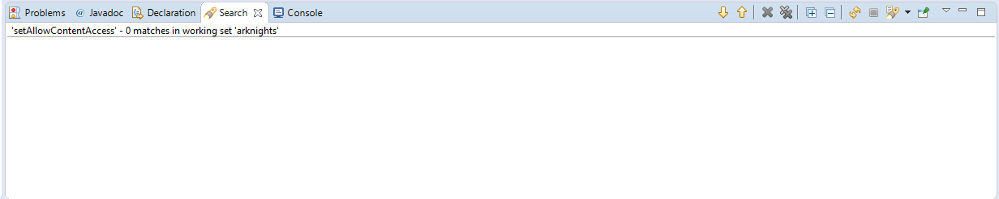

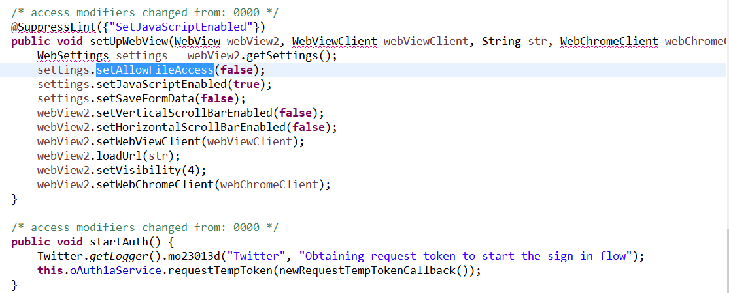

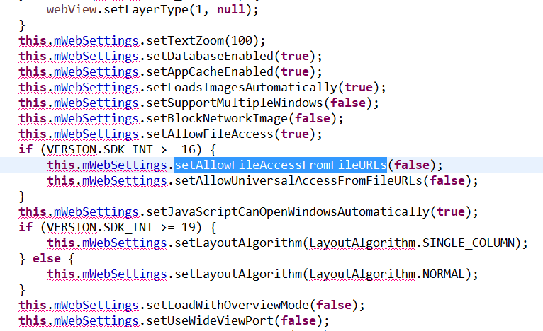

Could not find any of these functions used with true as a parameter.

While looking for loadUrl, I found that it’s mostly used with some StringBuilder/String object as a parameter, that is created from like 17 other strings as well like here for example:

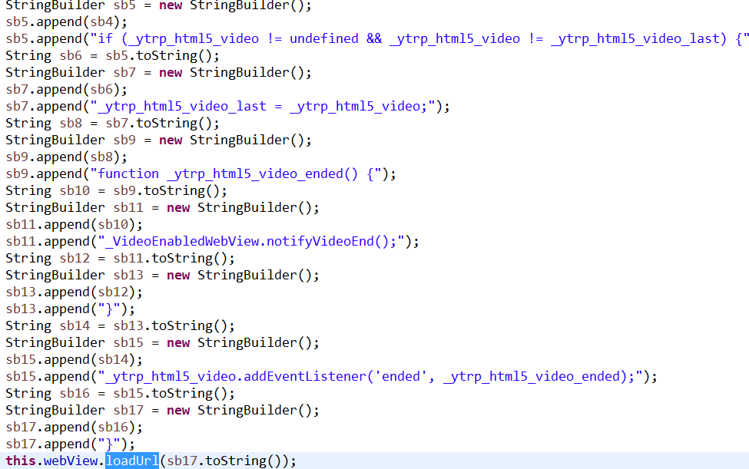

Kinda hard to figure out what the actual url will be in the end. But I did not manage to find any references to methods to get app’s resource catalog path in parts where url was being built.

1. Found addJavascriptInterface used in Bolts and Facebook SDKs.

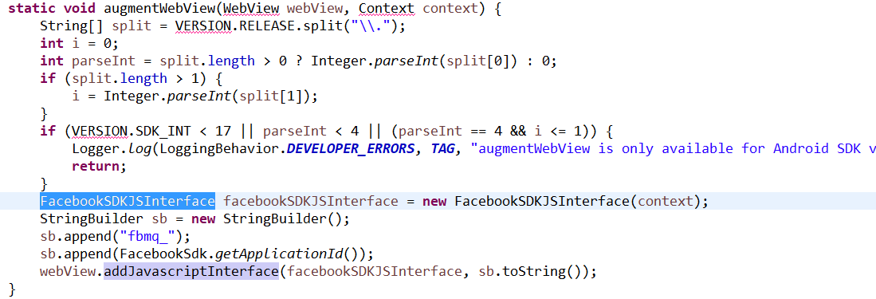

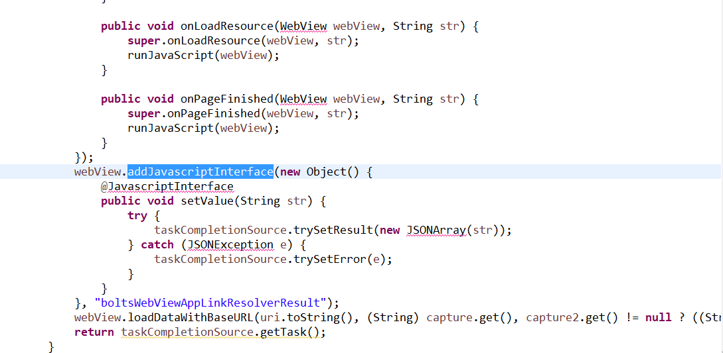

Can’t find a way, how can these ones be used to execute some malicious JavaScript.

1. In adjust SDK I found this class:

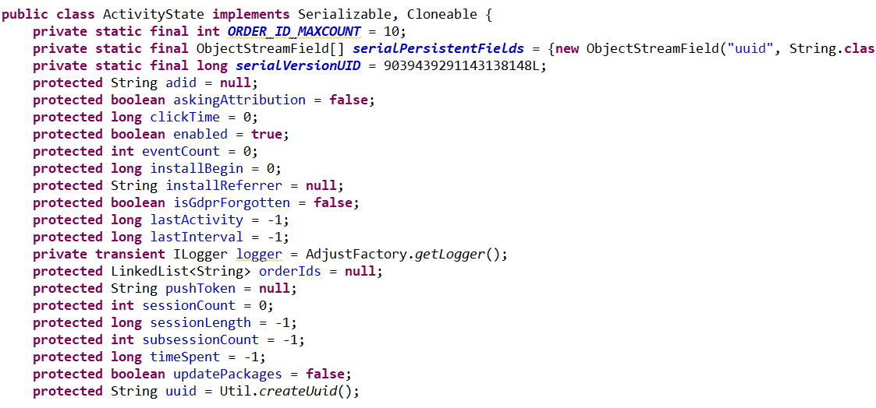

Push token seems like something important. Let’s see how this objects are serialized.

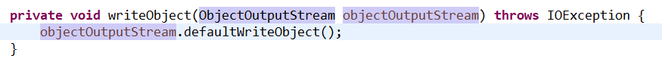

Oh well, doesn’t seem like any kind of encryption is applied to any of the data in this class. I found several classes like that in other SDKs as well, like:

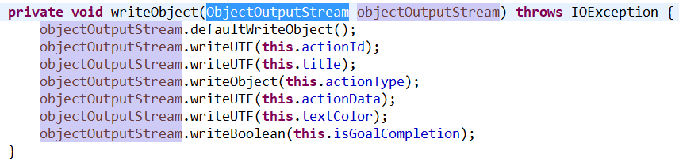

Though I don’t see any confidential data from my point of view in here.